
DRAFT TECHNICAL MEMORANDUM

ASM EA Hg Cookbook
PREPARED FOR: | BES PRGFX Project
PREPARED BY: | D.F. Cautley
COPIES:

Introduction
This document is a work in progress – it is incomplete in some important respects. In particular this reflects the author’s Private model setup.
This version of the cookbook describes working with the EA shared repository using Sparx EA and the HgSCC interface.

Collaboration Models
We will use a mixture of the Shared Model and Private Model deployments. In the Shared model, all EA users refer to the same EA database, usually a SQL Server. In the Private model, each user has his or her own EA database, either EAP or SQL Server.
City staff will use the Shared model and a central SQL Server database. Contractors and other off-site people will use a Private model.
These models are described in the Setting Up Version Control white paper and the EA user guide. Please read section 8.11 of the user guide. You may be able to get by without this investment of time but it’s a recommended read.

Getting Started
We assume you have EA up and running.
- If you haven’t already, Clone the Google Code repository to some repository location on your local disk. This will get the baseline database and all other PRGFX code. You can use an existing clone; but use the TortoiseHg interface to get the latest files. You know you have a good enough version if there are some XML files in a folder named EASCC. You will probably see more or different files than what is shown here.
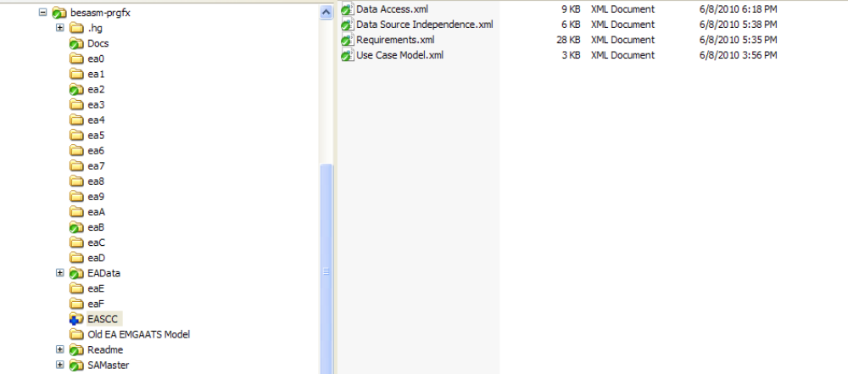
- Install the HgSCC interface. This utility gives you the version control API to Mercurial that EA is going to be looking for. There is a short article at http://alensiljak.blogspot.com/2010/04/mercurial-scc-provider-enterprise.html that describes how to get Sergant’s API. Be sure to download the version linked to from this page; it is an older version. Newer versions of the HgSCC project don’t support the interface API that EA needs. Just run the Setup.exe after you unzip the download.
- Connect to or obtain an already version controlled copy of the EA project file, and open it from inside EA. If you are using the Private model, do NOT put the EAP file in your SCC working directory or attempt to version this file.
You can get a baseline EAP file from the EAData / BaselineEAP folder from your Hg repository. Do not work directly in this folder.
You can also connect to a SQL Server hosted version of the project.
When you open the project for the first time it will ask you to configure version control; it may jump into the middle of the next step.
- Set up version control in EA. This information is stored in the local machine registry and so is specific to each user. The key thing you are doing here is telling your machine where your local working copy of the Mercurial managed data is.
Choose Project > Version Control > Version Control Settings

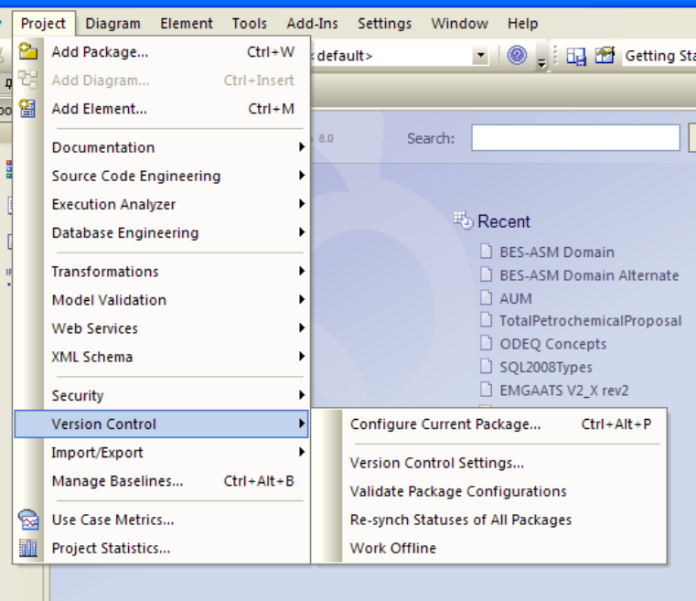
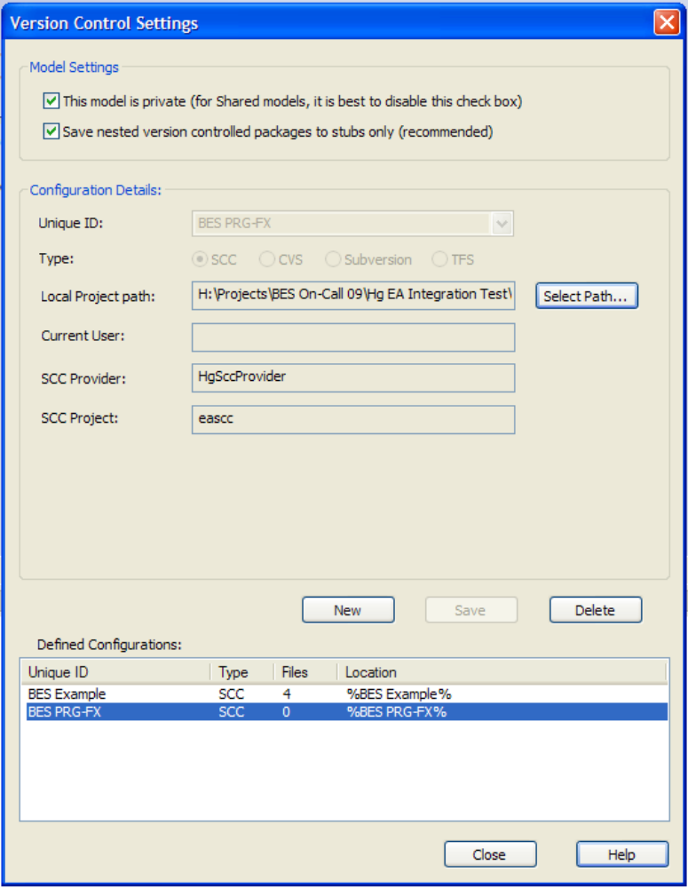
If you are working at BES, do _not_ check the “this model is private” option.
You MUST use the unique id as shown: BES PRG-FX. This ID must be the same across all clients everywhere.
The local project path is the EASCC / BES-ASM Domain folder in the Hg repository you cloned (or got the latest version of).
If your Mercurial SCC provider was successfully installed you’ll get that option to pick from. If there are SCC systems on your computer you could get other options but this is not likely for most of us.
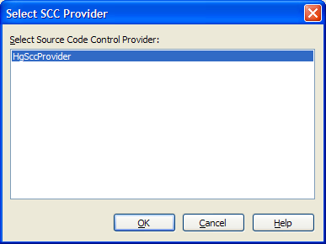

You’re ready to begin working with the controlled version of the EA project.

Working with a Controlled EA Project
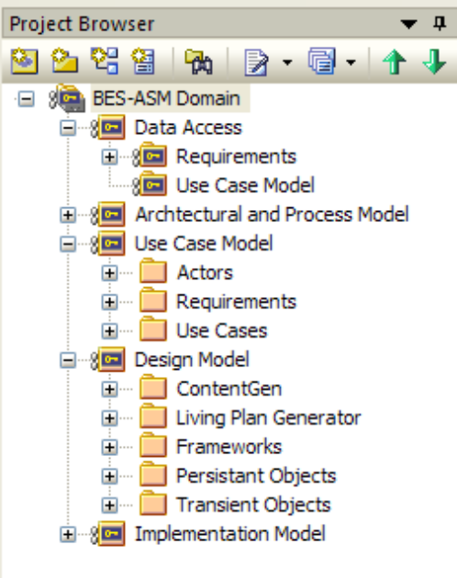
First, note that the icons for several packages are different in a version controlled project. They will indicate that the package is controlled, and either checked out or not.
You will not be able to work with a package or its contents unless it’s checked out.
The SCC actions are all under the right mouse menu of the package, under Package Control.
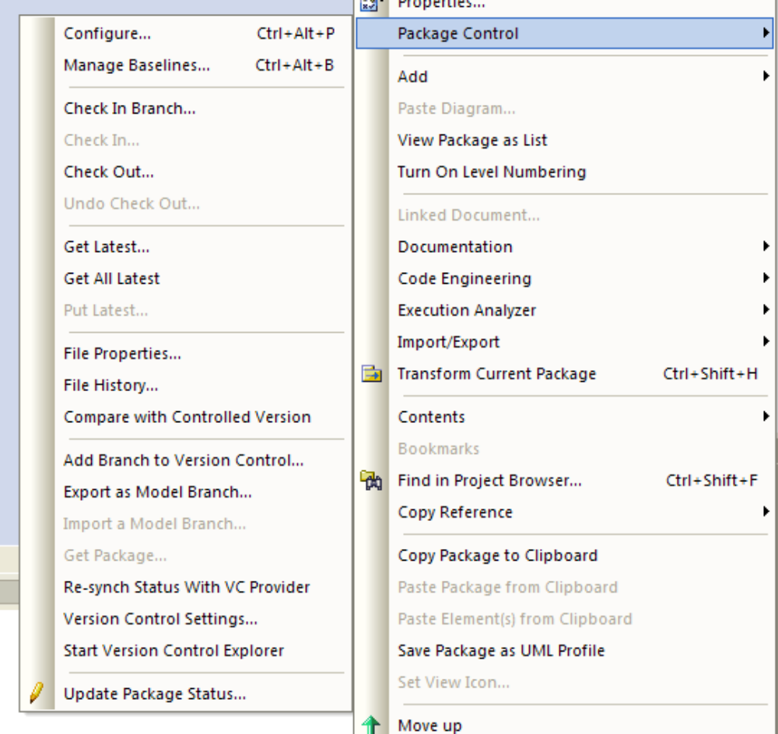
Note the Check In and Check Out options; also Get Latest.
Remember that Mercurial is a distributed SCC? Keep in mind that even when you check in a package, while this commits the change to your local repository this will NOT synchronize your local repository with the Google Code one. That requires a separate step using, for example, the TortoiseHg user interface.
This means among other things that for some other project you could have a completely local repository and do versioning for your EA projects without having to use Google Code.
A few of the menu items result in calls to the SCC provider that are not implemented in HgSCC; these seem to fail gracefully.
So, once you are set up, you can:
- From Windows Explorer, Pull the latest from Google Code to your machine.
- From EA, do a Get Latest on each package you’re going to work on.
- Check out a package.
- Make changes.
- Check the package back in.
- From Windows Explorer, synchronize (Push) your repository to Google Code.

